# Internet Explorer Download Help

1. Select **OK** for the Authorware Web Player security window.

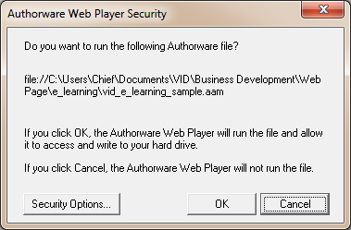

2. Select **Internet options from the settings menu ""**

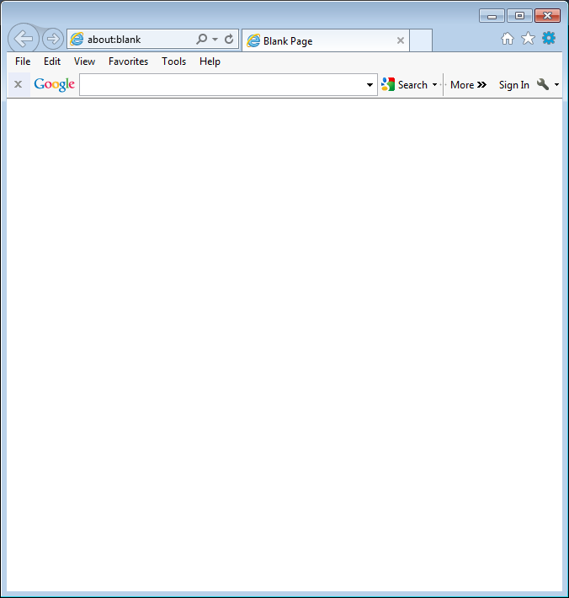

3. Select the "Security Tab"

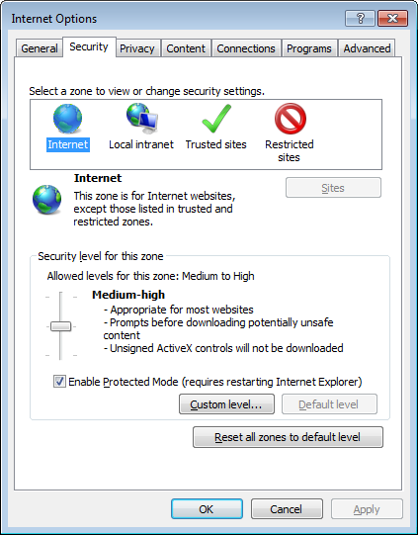

4. Select " "

5. Select "

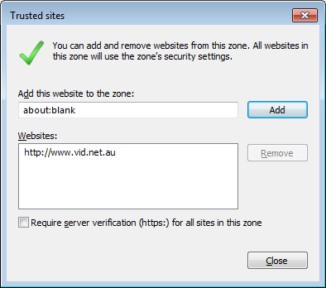

6. Select  or type in http://www.vid.net.au and select 

7. Select 

8. you may need to re-select "Download e-Learning" to run the file

VID are updating software hosting program to Adobe Captivate. Until then, if you need more assistance please do not hesitate to contact VID - information@vid.net.au